New intranet user guide
Important information available the ‘Need to Know ‘ menu and page tiles e.g. ‘Incident Reporting.’
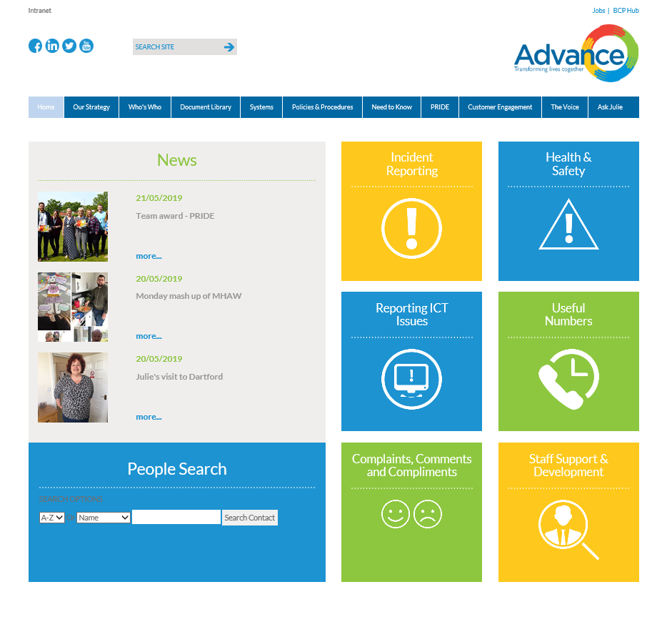

Information is available through side menus and sub menus on some pages.
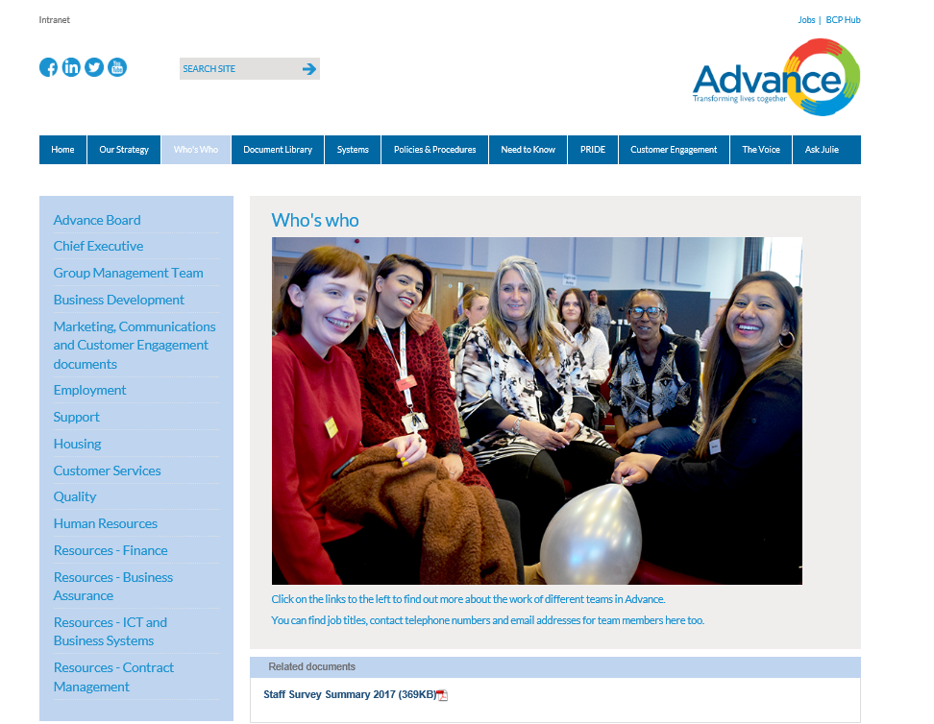
Some pages have related documents at the bottom of the page.

Searches
The site has four different search functions
- The top search menu searches site pages for content e.g. anything that is written on a page.
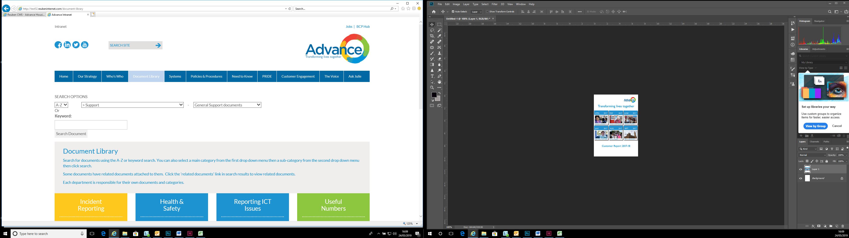

- The search functions in the document library returns results for all documents.
You can use the A to Z search function on this page to filter.
You can use the two drop down menus to filter search results by department and category.
Document library keyword or filtered search results include policies and procedures.
- The search functions on the policies and procedures page return results for policies and procedures only.
You can use the A to Z search function on this page to filter.
You can search by publication and renewal date.
You can use the drop down menu to filter search results by policies and procedures category.
Document library keyword or filtered search results do not include results for documents that are not policies and procedures.
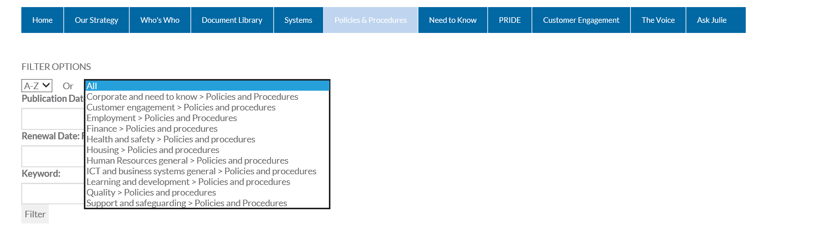
Some policies and documents have related documents attached to them. Click the white arrow next to ‘Related documents’ will open these documents in the list.
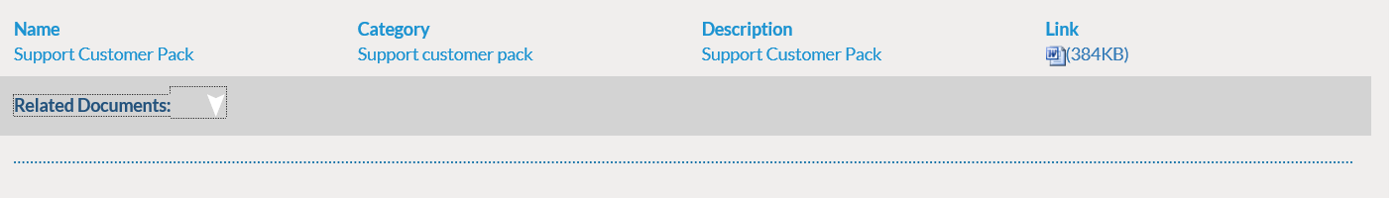
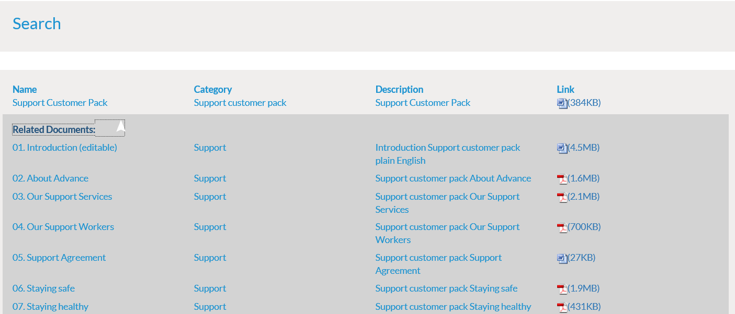
- The people search allows you to search for people who work for Advance. This takes information from ‘Active Directory’ so it is important to make sure your details are up to date. You can do this on the ‘Report ICT Issues’ page.
You can use the A to Z search function on this page to filter.
You can also filter by department, location and job title.
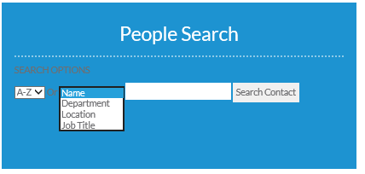
Give yourself a bit of time to learn about how the new intranet works.
Please send feedback or questions to marketing@advanceuk.org

Site management
The site has been developed by an external supplier with whom Advance have a support contract. This contract is managed by ICT.
Pages are managed by different departments. Content editors are named on the bottom of pages. If changes are requested to what pages say, content editors should be contacted. If documents appear in the wrong place or can’t be found please contact the relevant department.
To add or delete pages contact ICT.
To set up new users or remove existing users contact ICT.
To change, edit, add or remove photos from pages contact Michelle.Maddox@advanceuk.org or Richard.Brattan@advanceuk.org
To add a news story to the site contact marketing@advanceuk.org

