Quick Guide to Linking Customers to Staff on iplanit

Only Managers and Admin users have the Link facility

If you are a Manager your account on iplanit will automatically allow you to report an incident against the Customers attached to the same Location/Scheme Code that you are.

This logic does not apply to the Support Worker accounts and these staff will need to be linked to the customers that they work with and may be required to log an incident for. The linking can be taken off again so you may wish to link them just temporarily if they are just covering one shift at a scheme for example.

Process for Linking

From the main screen, click the Link to a Person

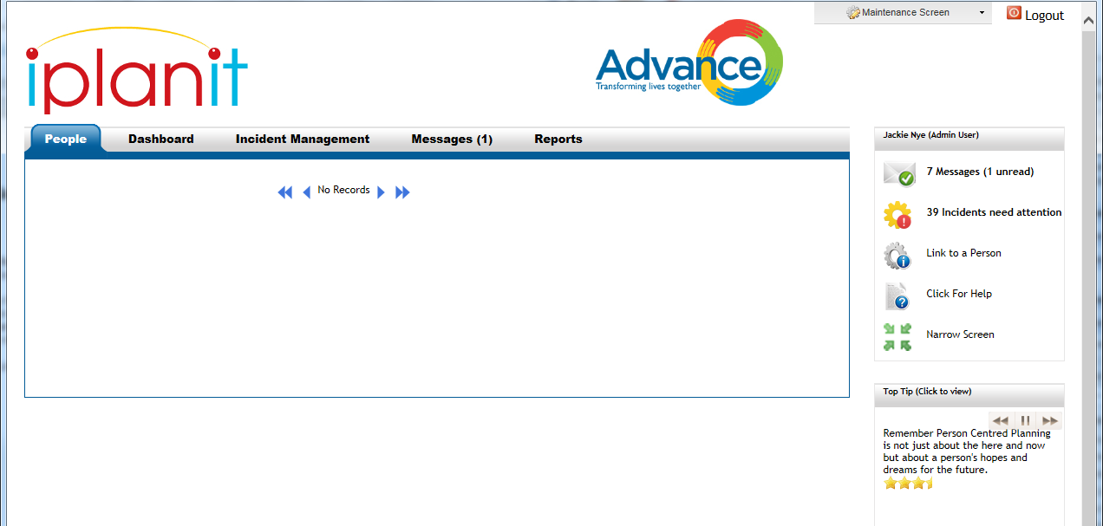

From the drop down choose the staff member to link the customer/s to.

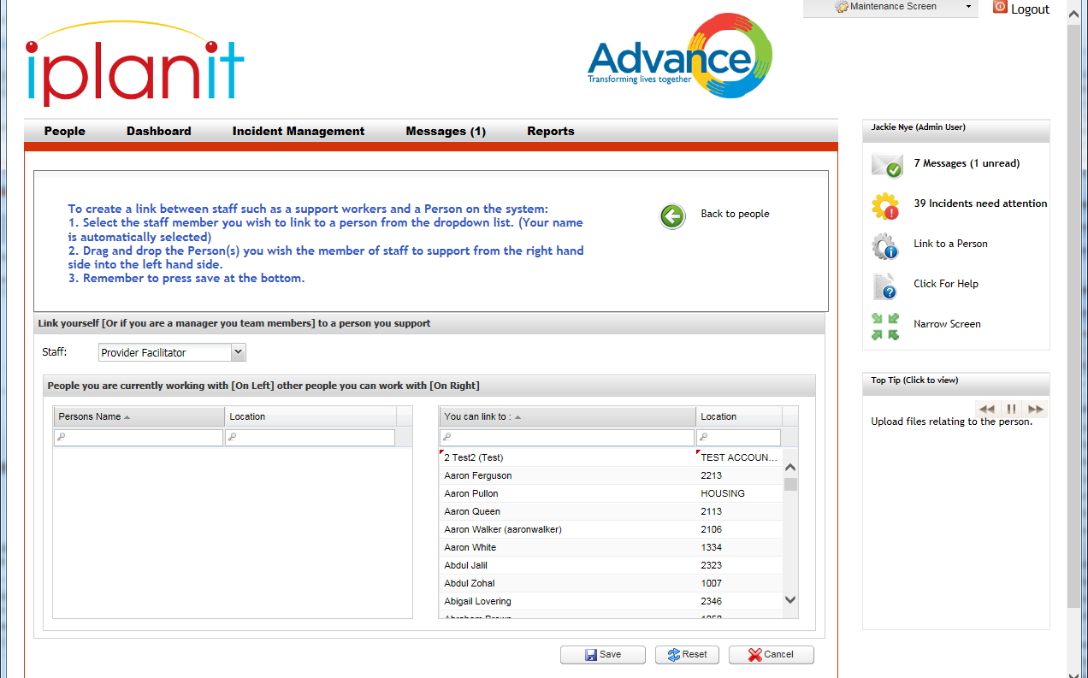

Use the search facilities in the ‘You can link to’ box on the right. You can search for a specific customer or search the location by typing in a scheme code or area.

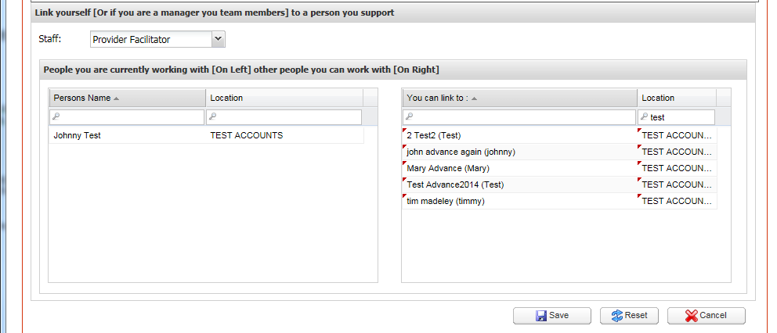

Click and drag the customer you wish to link to this member of staff from the right hand box to the left hand box. As shown above Johnny Test has been dragged across.

If you need to link more than one customer to the same staff member you can do this by using the Ctrl key on your keyboard. Highlight the first customer then hold down the Ctrl key and highlight the next one and so on. Release the mouse and the Ctrl key before clicking and dragging them all across in one move. Ensure you click within the highlighted area before dragging.

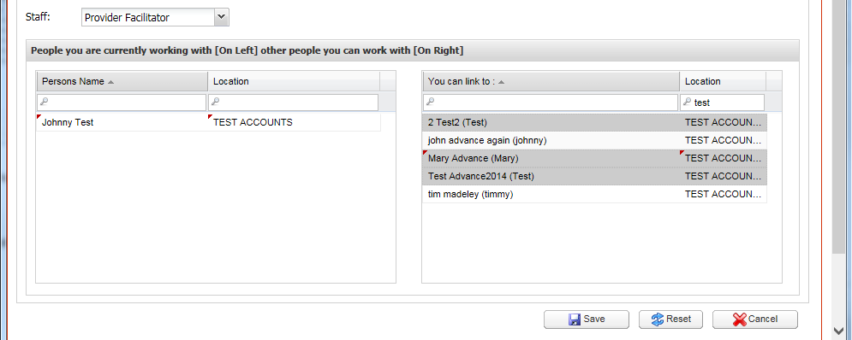

Check that the correct customers now appear in the left hand box and Click Save

You can remove customers from staff in exactly the same way but drag them from the left hand box to the right and then save.

