Incident and Accident Reporting Guidance

Contents

Reporting and Logging an Incident 2
Reporting Timescales: 2
Logging on to iplanit 3
Process for Logging of an incident – Stage 1 3
Adding Additional Information 5
Incident Event Log 6
Incident Alerts/Notifications 6
Process for Completing an Incident Follow up – Stage 2 7
Process for Completing Safeguarding Alert – Stage 3 9
Process for Completing Section 42/47 Enquiry 10
Process for Signing Off and Closing an Incident 10
More Options - not already covered above and only available to Managers 11
Delete Incident 11
Link Management 12
Not Visible to 12
Audit Logs 12
Print Incidents 13
Incident Letters – Sending an Incident and Accident Report Form externally 13

Reporting and Logging an Incident

It is everyone’s responsibility to report an incident to their Line manager when an incident has taken place and after the customer has been made safe.

An incident can be reported and logged by anyone

- Serious Incidents must be reported within 24 hours by phone to your line manager or oncall
- Incidents must be logged on the incident Management system (iplanit) within the correct notification period for the type of incident

There are three stages to logging and completing an Incident that require completing by the relevant staff members as detailed in the table below:

Area | Steps | Who is responsible for Completion
Support | Stage 1 – Initial Incident Report | Any staff member
Support | Stage 2 – Incident Follow Up | Manager
Support | Stage 3 – Safeguarding (if required) | Line Manager
Housing/Employment/Property Services/Corporate Departments | Stage 1 – Initial Incident Report | Business Assurance Administrator
Housing/Employment/Property Services/Corporate Departments | Stage 2 – Incident Follow Up | Manager assigned by BA Administrator
Housing/Employment/Property Services/Corporate Departments | Stage 3 – Safeguarding (if required) | As above

Reporting Timescales:

Severity of Incident | Reporting an Incident to Management | Logging an Incident on the Incident Management system
Minor Incident | Within 3 days (Email) | Within 3 days
Serious | Immediately (Email) | Within 48 hours
Death | Immediately (Tel & Email) | Within 48 hours

Follow ups are required to be completed within 10 days and the system will remind you if an incident has not been closed.

The following guidance will take you through the process for logging and completing an Incident on the new Incident Management System – iplanit.

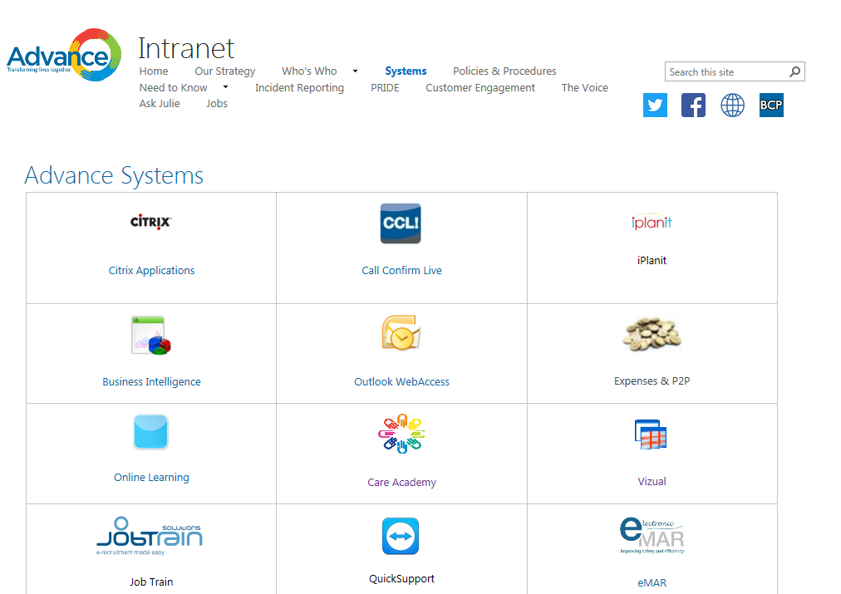
Logging on to iplanit

All Support staff should have a login for iplanit to allow them to be able to log an incident. Other staff may have a login or a nominated person for logging incidents.

There is a link on the Systems page on the Intranet to access iplanit.
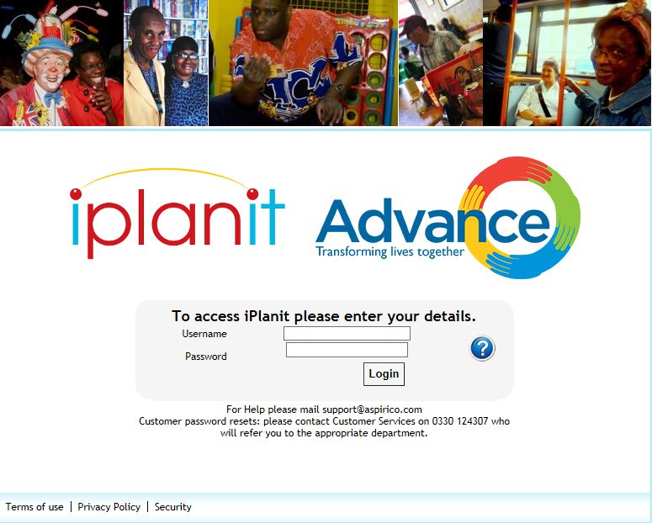

On the login page enter your username and password.

Usernames are usually your full name – firstnamesurname
For example: joebloggs

On initial login you will have a temporary password that you will be prompted to change.

Should you have any problems with your login please contact your line manager or regional administrator.

Process for Logging of an incident – Stage 1
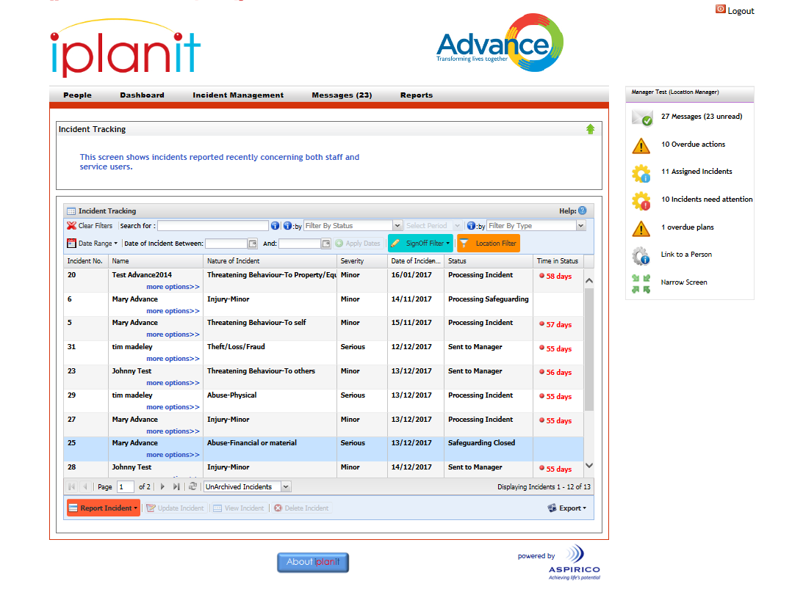
- Once logged in to iplanit click the Incident Management tab you will see the Incident Screen as shown here.

On this screen you may be able to see previously logged incidents or the page may be blank.
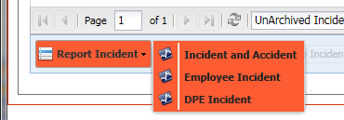
Select Report Incident –

From here you have 3 choices:

Incident and Accident – for all customer incidents
Employee Incident – for all employee incidents
DPE Incident – Any incident that involves Advance Data, Property or Equipment

Depending on which of the three forms you are completing the fields may differ slightly but on the whole they are very much the same. This guidance will take you through completing a customer Incident and Accident form but this should give you enough information to complete any of the forms.

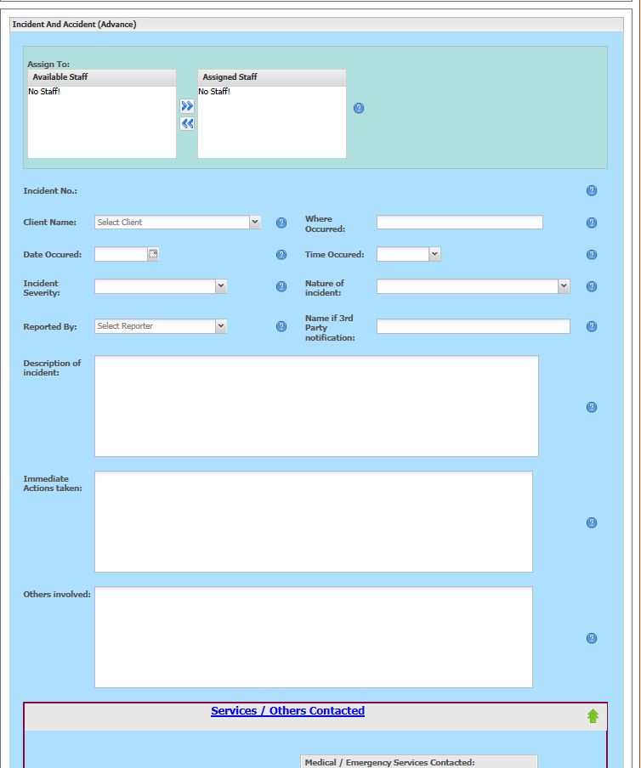
- Client Name - Select the name of the Customer who has been involved in the incident. Please note a separate form will need to be completed for each customer involved.

- Assign to – choose from the list who to assign the incident to – generally your line manager. Use the arrows to move from Available staff to Assigned Staff

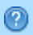
- All sections of the Incident Form should be completed in full, please use the help functions for simple guidance on completion of the form – indicated by the ?

- Where occurred – record exact location
- Date occurred – select from calendar
- Time – enter this in 24 hour format. If unknown please enter as NK
- Incident Severity – select either Serious, Minor or Near Miss
- Nature of incident – choose from drop down list
- Reported by – select either your name or the name of who informed you of the incident
- Name if 3rd Party notification – Name if third party notification e.g. family member
- Description of incident: The incident should be clearly explained so someone who did not witness the incident can understand exactly what has happened.
  - Use Dates/times where possible to clearly explain the facts
  - Keep it factual
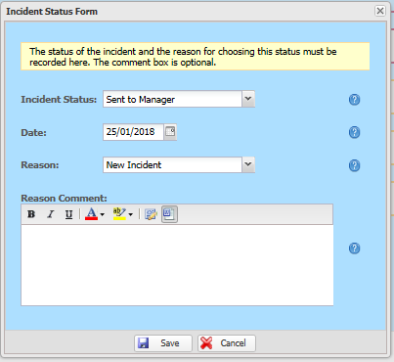
  - Include indicators or events that led up to the incident
- Immediate Actions taken – record what happened directly after the incident, if quoting someone, use their own words and make it clear who said what, again include timelines
- Others involved – make a note here of anyone else involved in the incident or N/A
- Services / Others Contacted - complete each section
- Save by clicking the Save button at the bottom of the screen and complete the pop up screen and click Save – please note if the pop up does not appear please return to the form as you may have missed a section. Any missed sections will be highlighted by a red box.
The incident form has now been submitted to the assigned Manager(s) and will have been assigned a unique incident number.

Adding Additional Information

Support Workers are only able to view Stage 1 of the incident form and once Saved and submitted they cannot go back in and amend the initial form. However Support Workers can view the form (View Incident), upload Media such as body maps or add additional information using the Incident/Accident Event Log. For example add in further detail such as having to contact the Doctor as the customer’s condition worsens after logging the initial incident.

Further information or documents such as a body map can be added at any point after an incident is saved by the reportee using the Incident/Accident Event Log or Media.

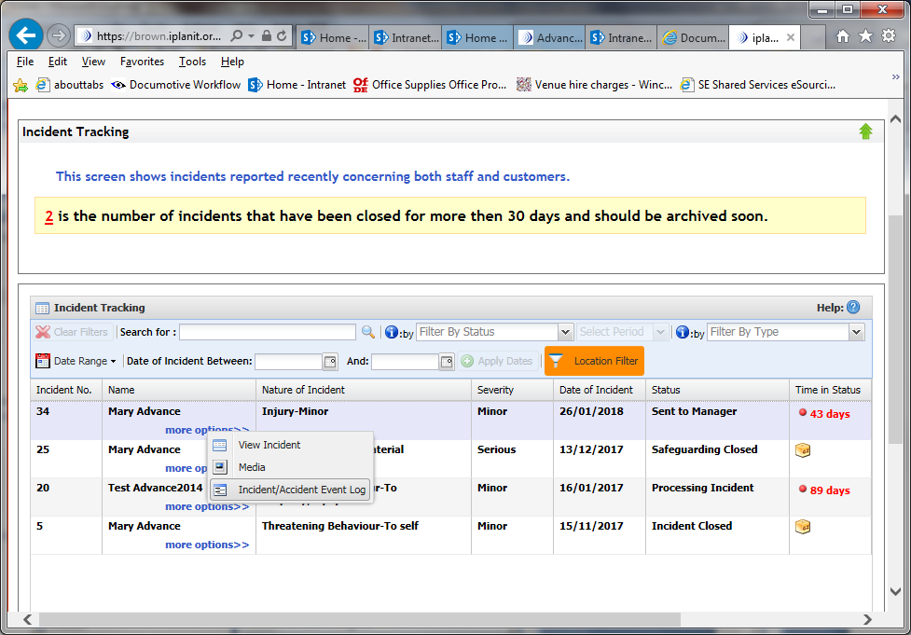
This is done by locating the incident from the Incident screen and going to ‘more options’ and choosing the relevant option.

Any document can be uploaded as Media but must be already saved to your computer.

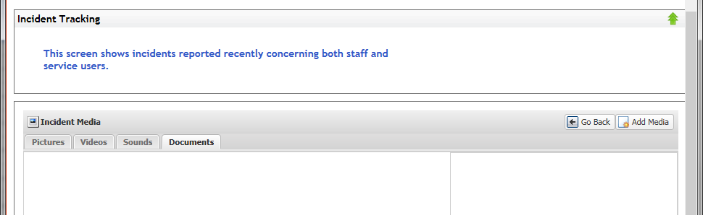
- From the more options menu choose Media

- Choose the documents tab and click Add Media

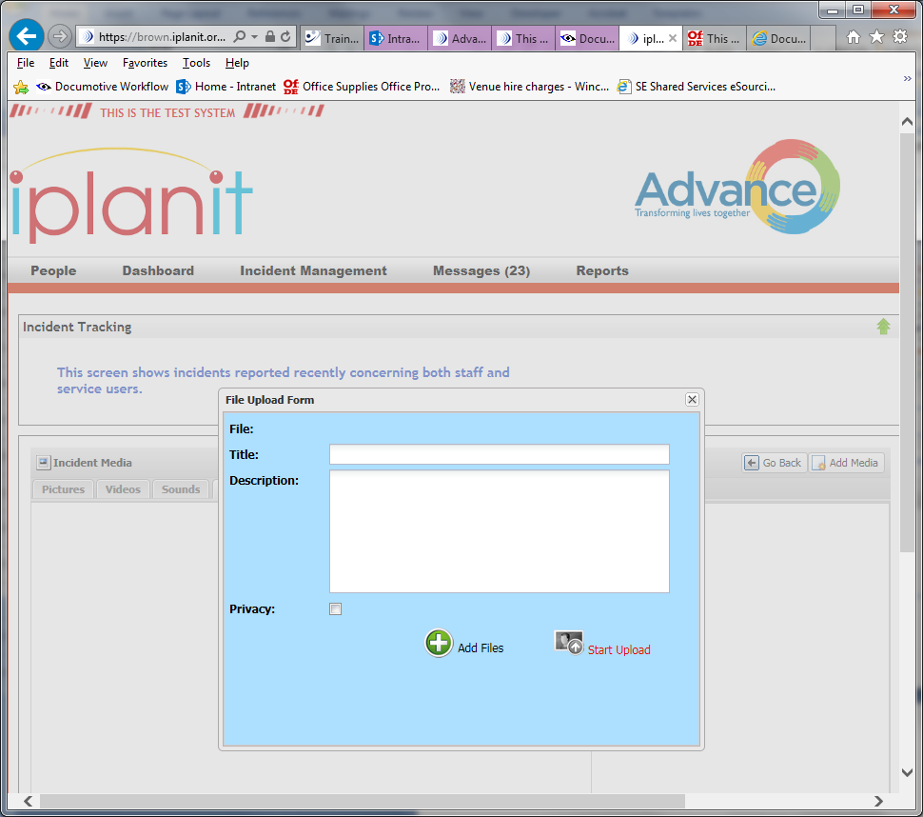
- From the File Upload Form click Add Files

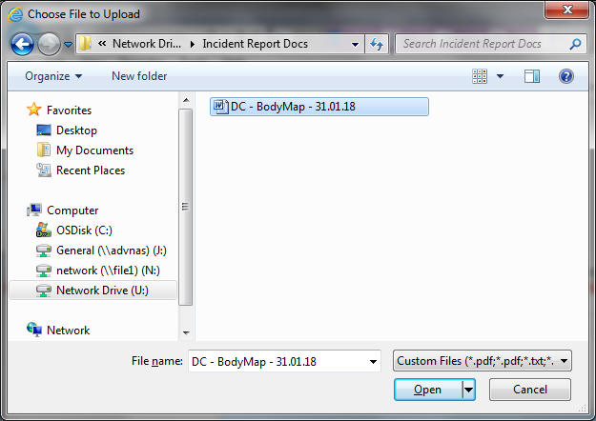
- Locate the required file from your computer system and click Open

- Type in a Title and a description, these are Mandatory fields

- Click Start Upload

Once complete close this window by clicking on the X

Click the Go Back button to return to the main Incident Tracking screen.

Incident Event Log
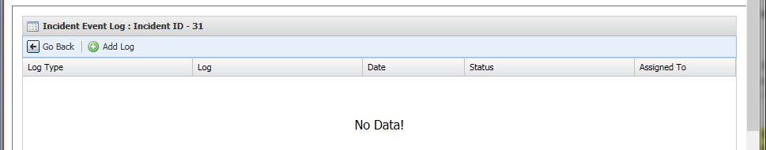
- From the more options menu choose Incident/Accident Event Log

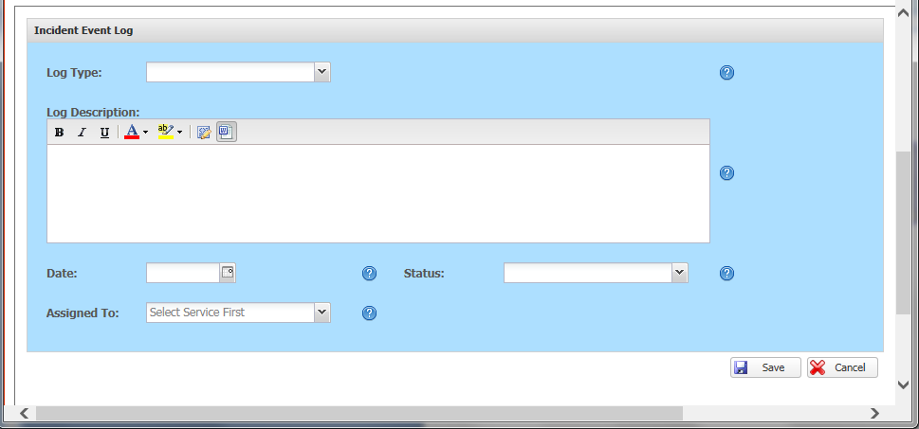
- Click Add Log

- Complete all sections with all the details and click Save

A completed Event Log:

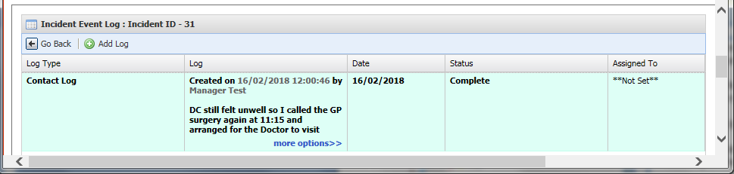

Incident Alerts/Notifications

Once the initial incident has been saved the person(s) it was assigned to will receive an email alerting them to the fact that they have a new incident on the system. They will be required to login to iplanit to view this incident and it will be indicated by the status of Sent to Manager.

Process for Completing an Incident Follow up – Stage 2

A follow up can only be completed by a manager. If a manager is the person recording the initial incident (Stage 1) and the incident has been dealt with and any actions completed at the time of logging then Stage 1 and Stage 2 can be completed simultaneously and the incident closed.

Follow ups are required to be completed within 10 days and the system will remind you if an incident has not been closed.

- After receiving an email alerting a manager that they have been assigned a new incident, the manager will need to login to iplanit. (See page 3 – Logging on to iplanit)
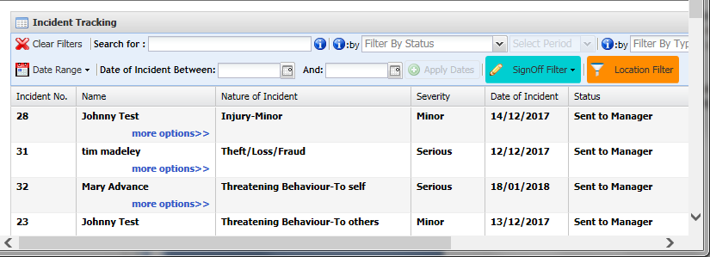
- New incidents will be shown with the status of Sent to Manager

- Click on the incident that requires updating and from the ‘more options’ menu choose Update incident

Please note if you have been assigned the incident for information only you can choose View Incident from ‘more options’.

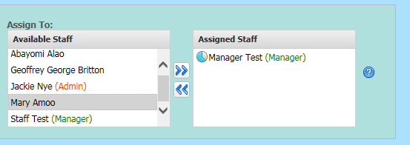
- After reading through the incident and before completing the follow up section, double check that all the initial details are correct i.e. is the incident category correct? If not amend where appropriate

- Check that the incident has been assigned to the correct departments/personnel in accordance with the Advance Incident Notification tables and amend where required.

- If you are in a position to complete the follow up section (Stage 2) continue and complete each section. Remember to use the Help menus to guide you to what information is required.

- Safeguarding Alert – Yes / No
- Date Notified - the date the Safeguarding was notified
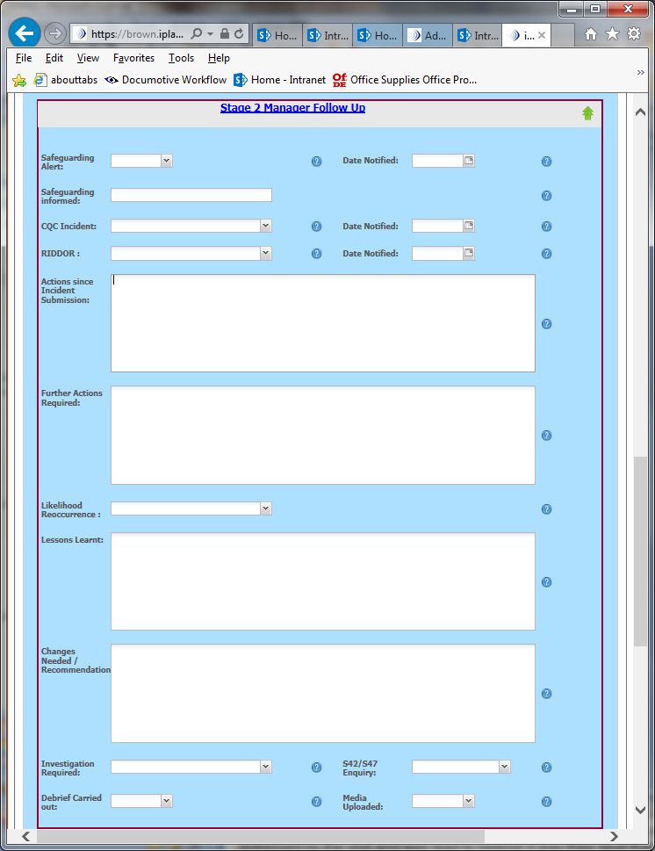
- Safeguarding informed – name of who was notified
- CQC Incident – Yes / No / N/A
- Date Notified – Date CQC notified
- RIDDOR – Yes / No
- Date Notified – Date of RIDDOR notification
- Actions since Incident Submission – All actions should be clearly detailed and explained.
  - Use Dates/times where possible to clearly explain the facts
  - Detail who has been contacted and when
  - Include details such as hospital admissions etc
  - Have any customer documents been updated as a result of the incident?
- Further Actions Required – Clearly detail any further actions that are required before the incident can be closed
- Likelihood of Reoccurrence – Choose from the drop down list i.e. unlikely, likely
- Lessons Learnt – Clearly detail any lessons learnt and any new processes that have been put in place
- Changes Needed / Recommendation – Detail any follow learning either for staff, or the organisation, including learning, training required, policy change etc
- Investigation Required – Yes / No
- S42 / S47 Enquiry – is this being progressed to S42 / S47 enquiry – this may need amending in the future
- Debrief Carried out – Yes / No – if yes please note how and when carried out in the description and upload any relevant documents using the media upload option
- Media Uploaded – please indicate here if any documents have been uploaded

Once you have completed all sections ensure you click the Save button at the bottom of the document screen (after the Section 47 Enquiry).

Please note if the pop up does not appear please return to the form as you may have missed a section. Any missed sections will be highlighted by a red box.
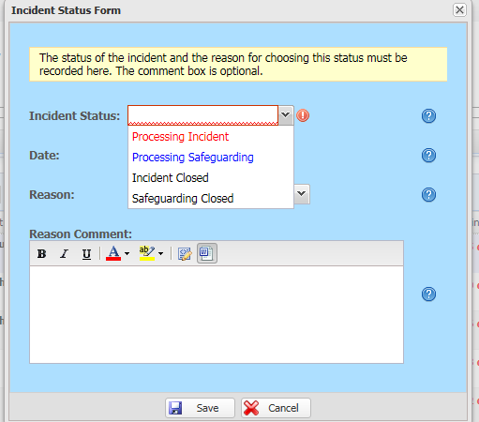
- Change the Status – it is important that managers amend the status of an incident to show its current progress. This is done by choosing the Change Status option from the ‘more options’ menu.

This is especailly important for reporting purposes.

Amend as follows:

 |  | Change Status to:
Incident has been read and checked | Stage 2 - Follow up not completed or only partially completed | Processing Incident
Incident has been read and checked | Stage 2 - Follow Up - Completed | Incident Closed
Incident becomes a Safeguarding | Stage 3 – Safeguarding Alert not completed or only partially completed | Processing Safeguarding
Incident becomes a Safeguarding | Stage 3 - Completed | Safeguarding Closed

Process for Completing Safeguarding Alert – Stage 3

If the incident that has been raised as a Safeguarding concern Stage 3 needs to be completed by the manager.

This section is fairly straightforward and all sections are required to be completed.

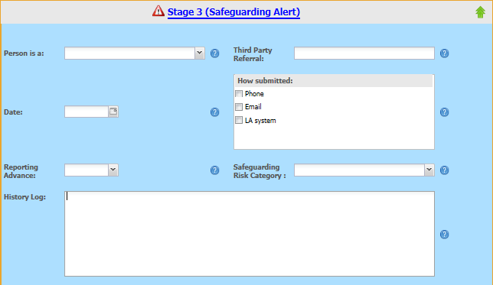
- Person is a: choose from the drop down menu – if you choose other please give more detail in the History Log
- Third Party Referral: if the referral was made by a third party include their name here
- Date: Date of third party referral
- How submitted: tick against - how was the concern submitted
- Reporting Advance: Yes/No - is the concern against Advance
- Safeguarding Risk Category: Chose the primary reason for the Concern from the drop down menu
- History Log: Ensure that the log is completed clearly and comprehensively – including:
  - dates and times of all communication (including date LS first responded to concern)
  - who contacted who
  - how contact was made
  - details of any contact

History Log Example:

21/02/18 – 10 am – Jane McDonald from LA phoned to confirm they had received
our referral
22/02/18 – 3.05pm – Email received to confirm that the LA has adopted this as a
formal safeguarding (Section 42 Enquiry)

- Click Save – Always remember to click save before closing the form if you have made any changes.

Process for Completing Section 42/47 Enquiry
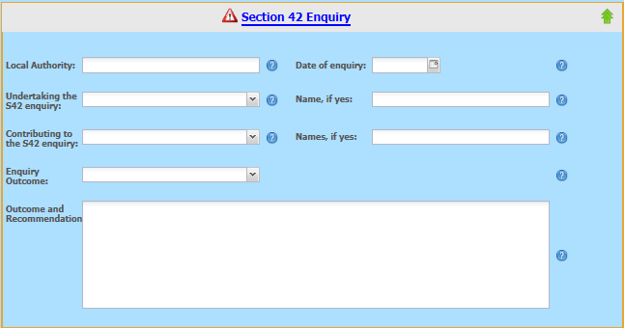
Should a Safeguarding concern result in an enquiry this section also requires completion. Section 43 refers to adults and Section 47 is for children only.

- Local Authority: Name of leading Local Authority
- Date of enquiry: Enter enquiry date
- Undertaking the S42 enquiry: Yes/No – indicate if Advance are undertaking the S42 enquiry
- Name if yes: if yes above enter the name of lead person from Advance
- Contributing to the S42 Enquiry – Yes/No – indicate if Advance are contributing to the enquiry
- Name if yes: list the names of any Advance staff expected to contribute
- Enquiry Outcome: Select the relevant outcome from the drop down menu
- Outcome and Recommendation: Please include any details and recommendations from the enquiry
- Save – Click to save all amendments.

Process for Signing Off and Closing an Incident

Before an incident can be closed, all those that have been assigned the incident are required to Sign Off the Incident. Please check that an incident has been properly recorded and processed before Sign Off.

In this example the incident has only been assigned to the test manager.
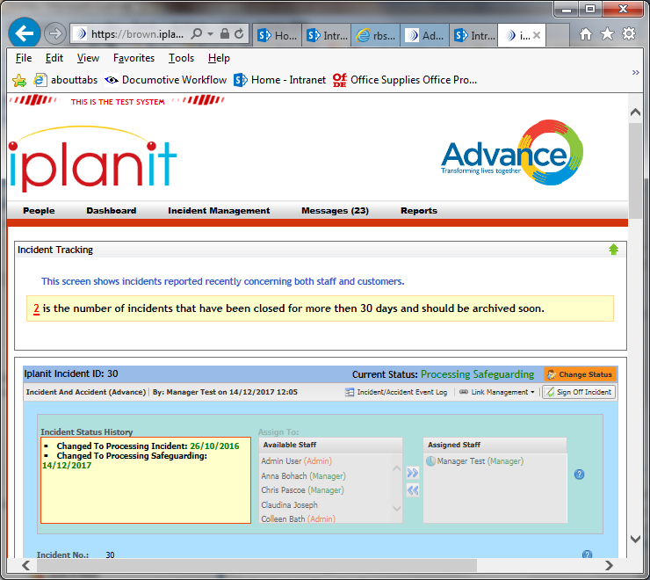

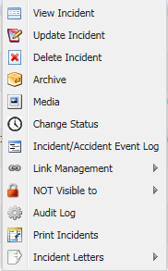

If an incident has been Assigned to you, this will have been done in line with the Advance Notification requirements. (See Notifications tables)

If you have received a notification you will need to log in and view the incident and then Sign Off Incident.

- From the More Options chose View Incident – if you are have been sent the incident for information only and after reading feel you do not need any further involvement you can click the Sign Off Incident button
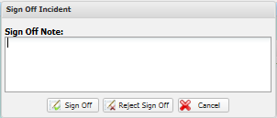
- Add any relevant notes
- Click the Sign Off button.

To Close the incident the status needs to be changed to either Incident Closed or Safeguarding Closed.

The Change Status menu can be activated either from within the View option, so can be completed at the same time as Signing Off an incident or from the More Options menu.

More Options - not already covered above and only available to Managers

Delete Incident

If you are able to see this option, please do not use it. We should never be required to delete an incident but if you think that there could be something that needs removing please contact your Area Manager to discuss.

Link Management
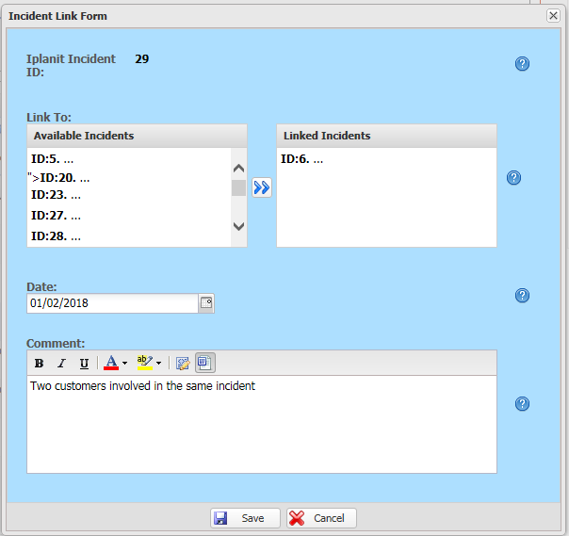
The system will allow incidents to be linked.

From one of the Incidents that you wish to link chose Link Management from the More Options menu.
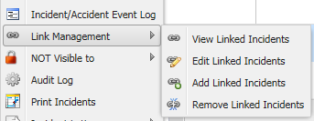

Chose the relevant incident/s from the left hand box and click the arrows in the middle to move them over the right box.

Click Save. These are now linked but can be edited or unlinked at a later date if required.

Not Visible to

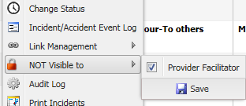
This tool is useful if you have an incident that due to its nature you do not wish all staff to be able to see. For example a confidential incident.

If this is the case from the More Options, go to NOT Visible to and remove the tick from the relevant staff member which will make it not Visible to that person.

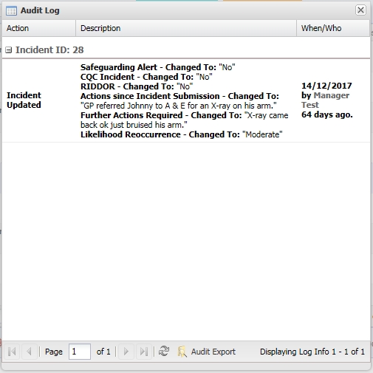
Audit Logs

The audit log shows the history of all changes that have been made to an incident.

Print Incidents

In its current format this option is not currently being used.

Incident Letters – Sending an Incident and Accident Report Form Externally

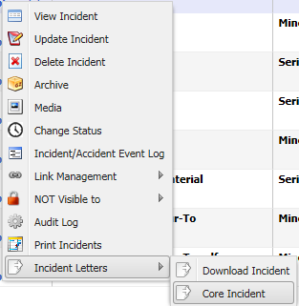
If a Manager is required to send a copy of an incident externally, the Incident letter option should be used. Names can be changed to initials if required and all documents must be sent securely through the Egress system.

From More Options chose Incident Letters

Core Incident – includes only the initial incident report and should be used for sending to external organisations

Download Incident - includes all the sections

The Incident Letters downloads as a Word document. Please double check the format of the document and adjust if required before sending externally.

Please send in any feedback for improving this guidance to Chris Pascoe – chris.pascoe@advanceuk.org

